page2image568

Tableau

Lesson-End Project Solution



**Product Analysis**

**Step 1:** Create a table with category and year of order date in the rows shelf, and month of order date in the columns shelf. Rename the worksheet as “Product Heat Map.”

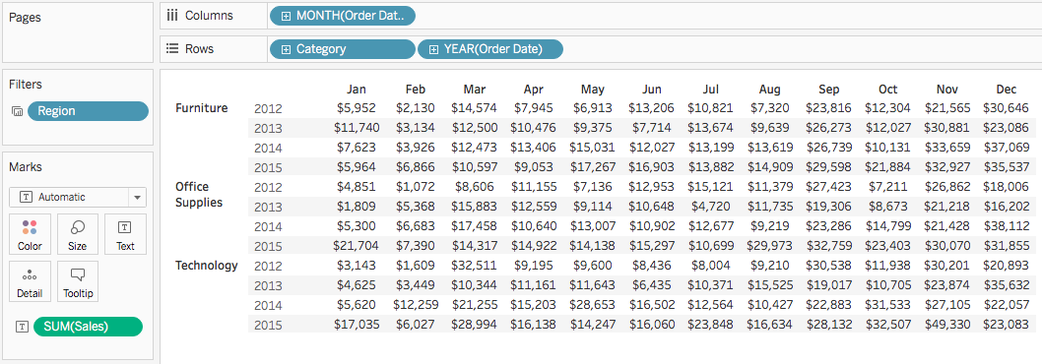

**Step 2:** Use the “Show Me” feature to change the table into a heat map and change the color coding to “Red–Green Diverging.”

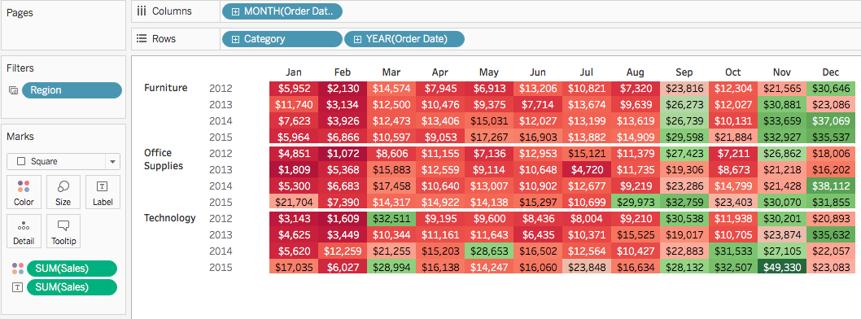

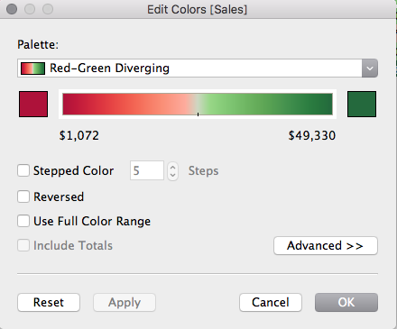

**Step 3:** Create a table with category, sub-category, and product name on the rows shelf and segment on the columns shelf. Add profit ratio and sales measures to the columns shelf. Add region to the filter shelf. Name the worksheet as “Product Scatter.”

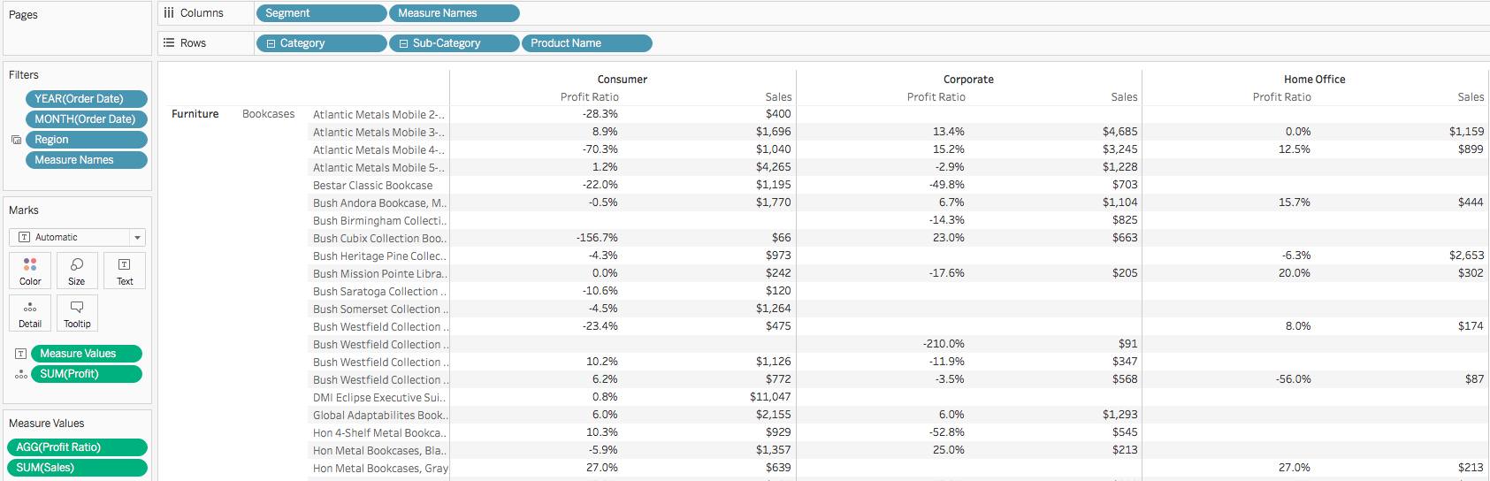

**Step 4:** Use the “Show Me” feature to change the table into a scatter graph. Change the color coding to “Red–Green Diverging.” Add a reference line that shows the median value of sales in each row.

